**AWS Challenge**

* **Launch one EC2 instance using Amazon Linux 2.**

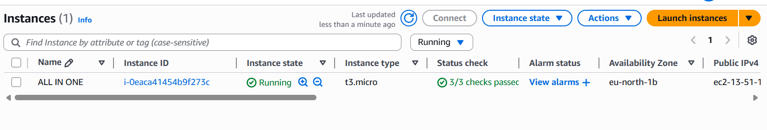

* **Install Docker.**

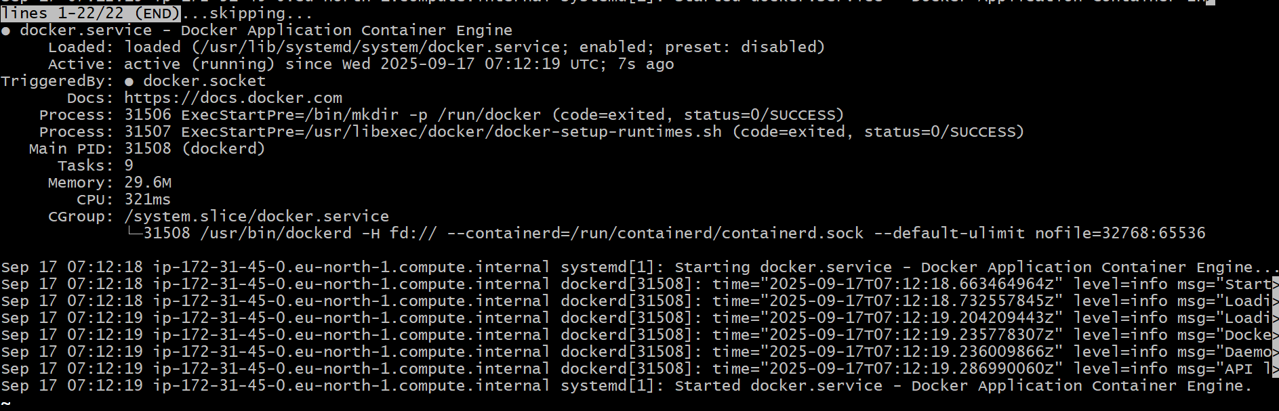

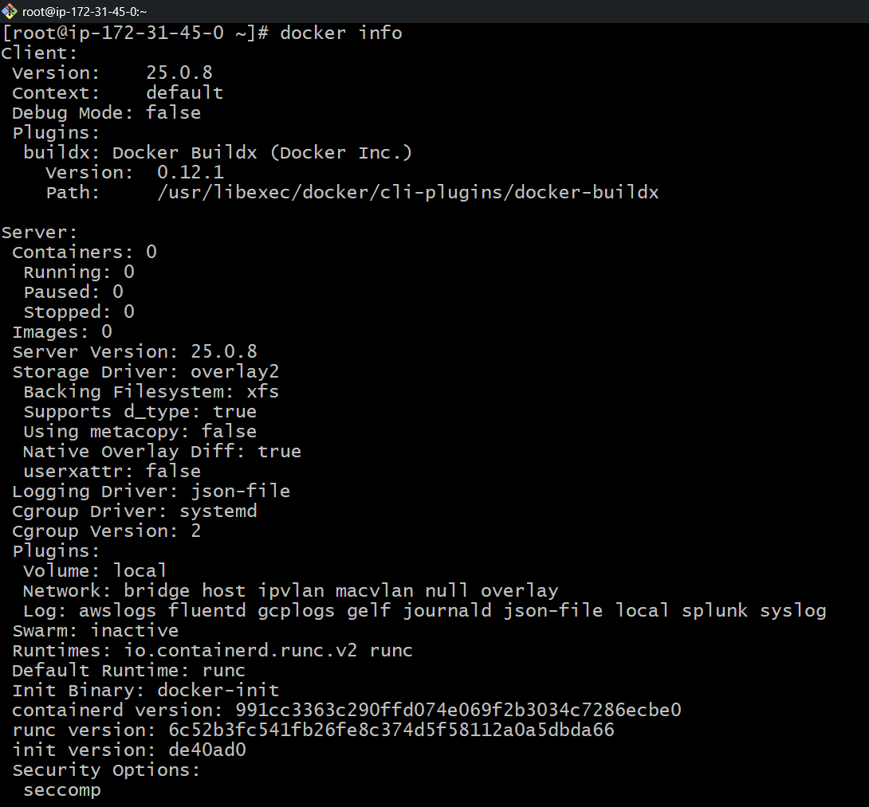

* **Install Jenkins.** 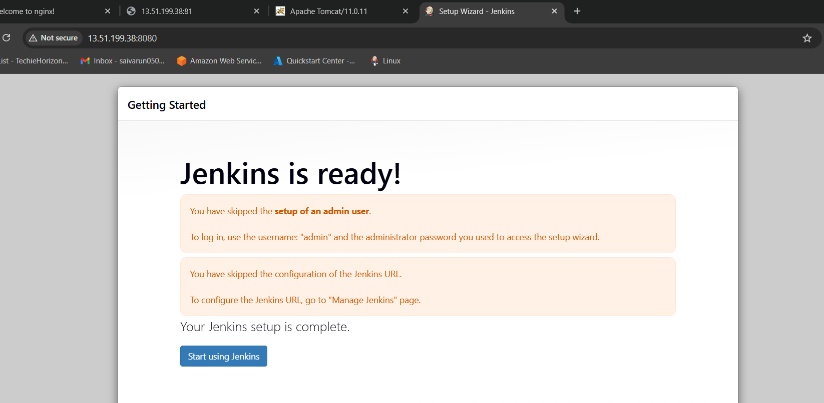

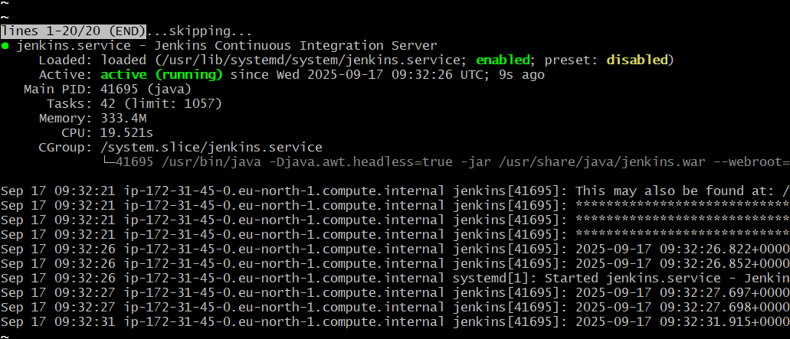

sudo wget -O /etc/yum.repos.d/jenkins.repo \https://pkg.jenkins.io/redhat-stable/jenkins.repo

sudo rpm --import <https://pkg.jenkins.io/redhat-stable/jenkins.io-2023.key>

sudo yum upgrade

# Add required dependencies for the jenkins package

sudo yum install java-17

sudo yum install jenkins

sudo systemctl daemon-reload

* **Install Apache.**

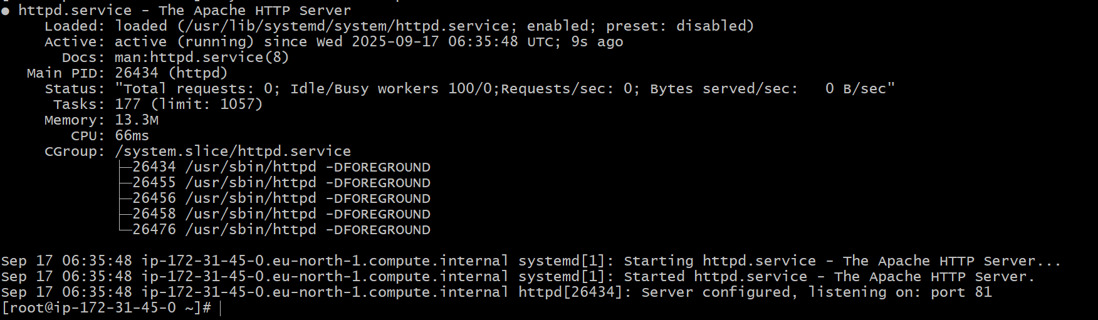

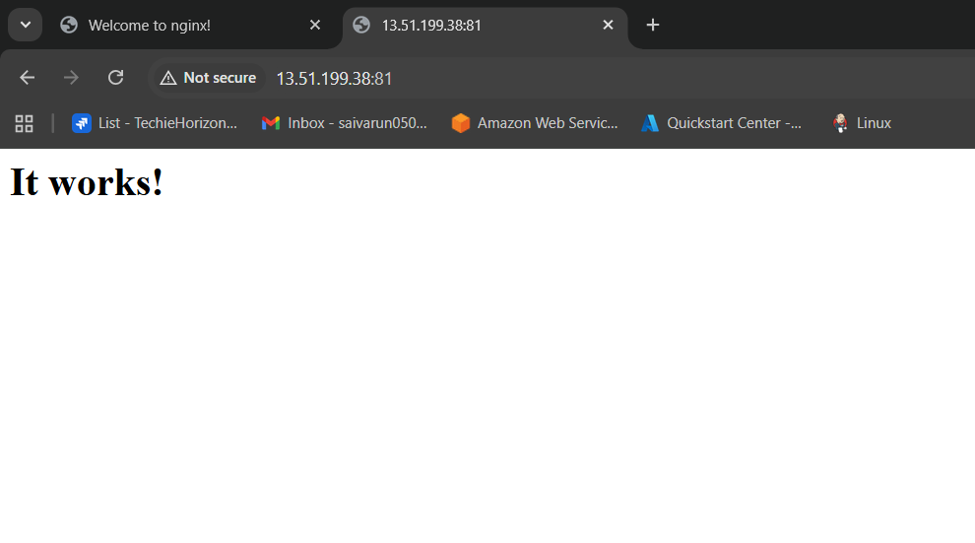

* **Install Nginx.**

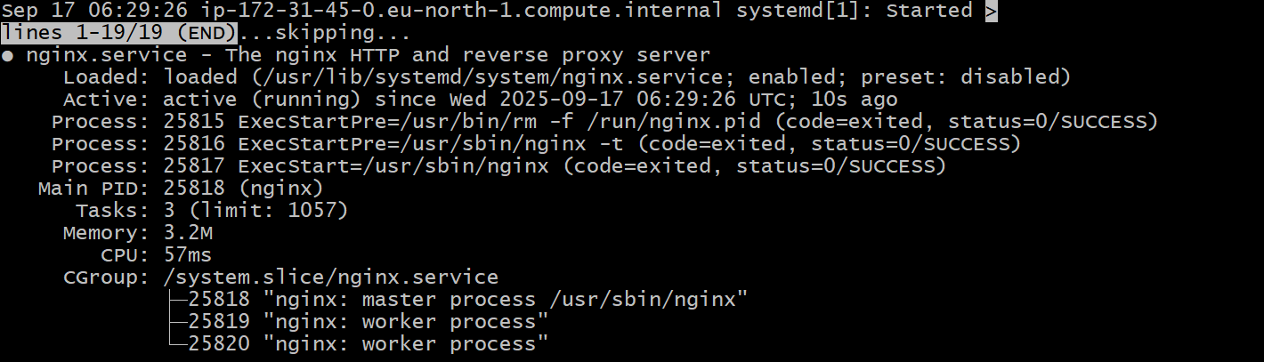

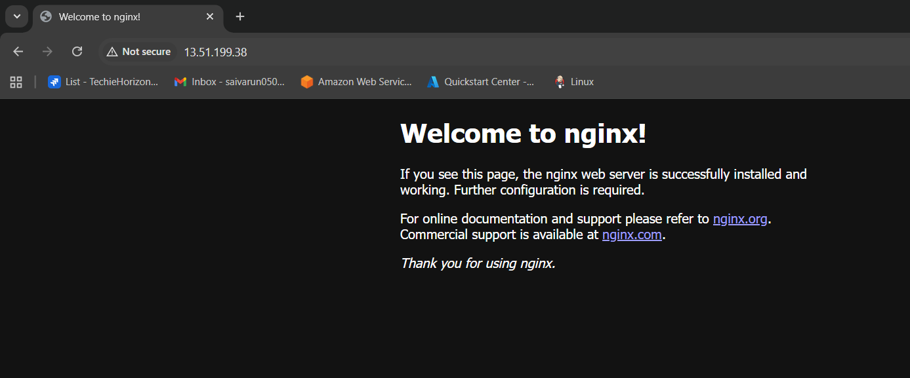

* **Install Apache Tomcat.**

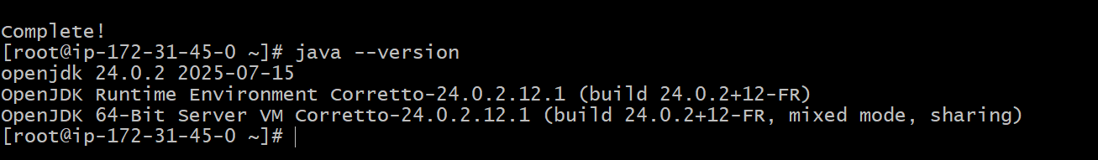

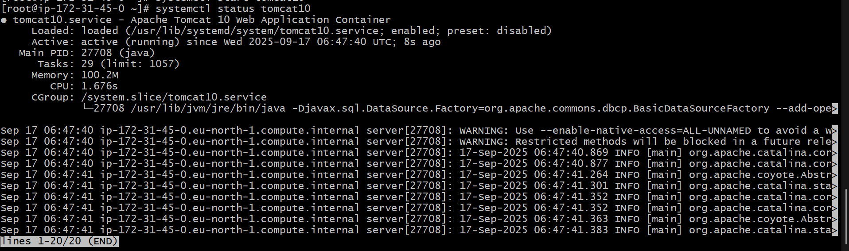

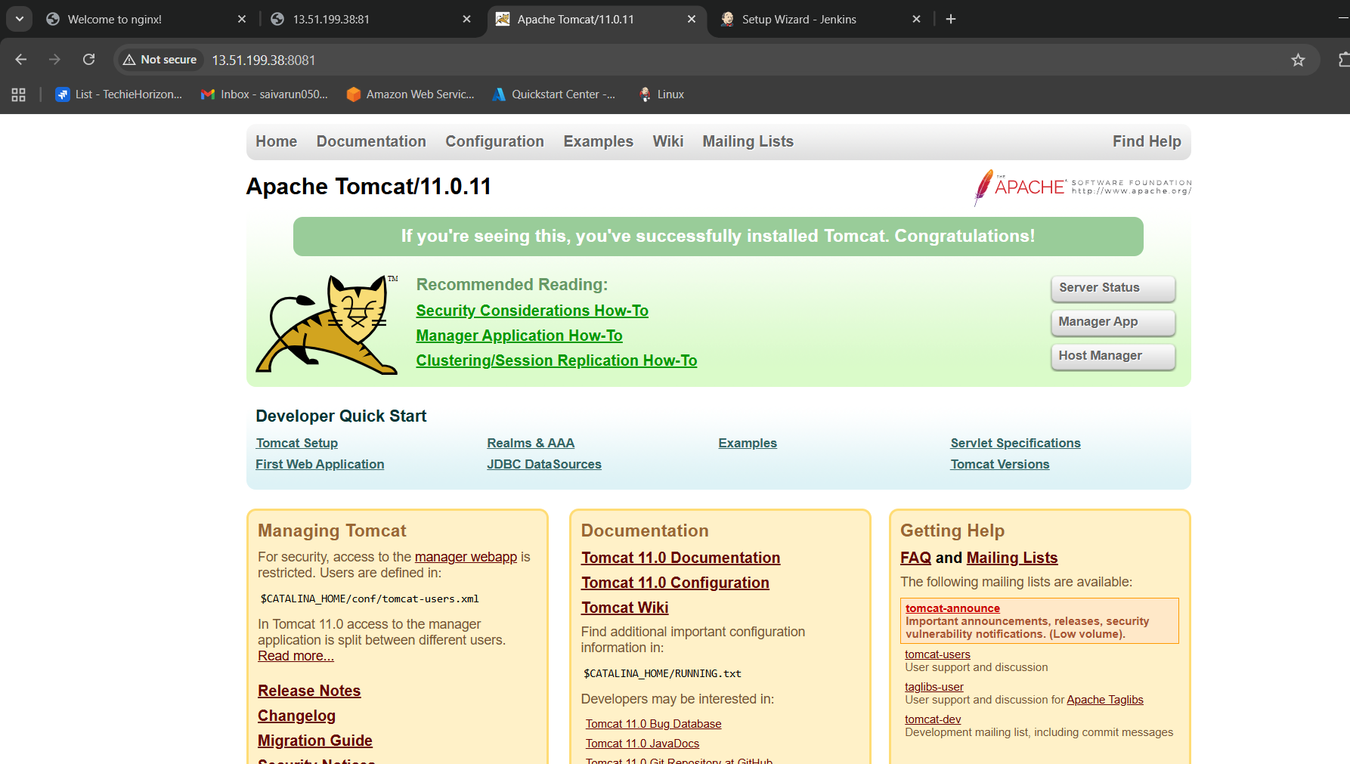

* **Yum install java**
* **Java –version**
* **wget** [**https://dlcdn.apache.org/tomcat/tomcat-11/v11.0.11/bin/apache-tomcat-11.0.11.tar.gz**](https://dlcdn.apache.org/tomcat/tomcat-11/v11.0.11/bin/apache-tomcat-11.0.11.tar.gz)
* tar xzvf apache-tomcat-11.0.11.tar.gz
* **mv apache-tomcat-11.0.11 tomcat11**
* **cd tomcat11/bin/**
* **./startup.sh**